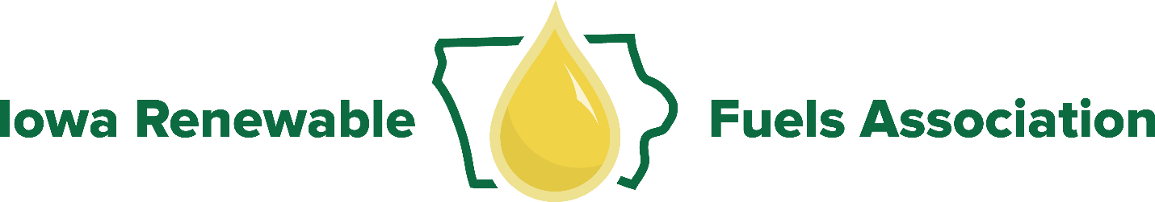

Iowa Renewable Fuels Association Meeting
IRFA Conference Room
5505 NW 88th Street
Johnston, Iowa 50131
December 13, 2017

8:00 am Breakfast
8:30 am Convene

Agenda

1. Regular Order
- IRFA Anti-Trust Policy/ Independent Board Member Policy
- Reading of Minutes (September 7 Board Meeting)
- President’s Report – Eamonn Byrne
- Treasurer’s Report – Bill Howell
- Executive Director’s Report – Monte Shaw
- Members’ Update

2. Association Business
- IRFA Nominating Committee
- Election of IRFA Officers and Executive Committee
- 2018 IRFA Board Meeting Dates
- 2018 IRFA Member Dues
- 2018 IRFA Budget
- IRFA Member PACs
- IRFA Renewable Fuels Summit
- 2018 Biofuels: Science and Sustainability Tour
- 2018 Members Day
- Iowa Monarch Conservation Consortium
- Communications Update

3. Issue Discussion
- State Legislative Issues
- Federal Issues Update
i. RFS2
ii. E15
iii. Tax Credits (Biodiesel, Cellulosic)
iv. Farm Bill Programs

- State Trade Associations Meeting/Governors’ Biofuels Coalition
- International Trade
- High Octane Ethanol Blends/Optimized Biofuel Engines/FFVs
- ASTM Updates

4. Committee Reports
- Ethanol Promotion Committee
- Biodiesel Promotion Committee
- Membership Committee
- IRFA PAC Committee
- Co-Products Committee
- Safety Task Force
- Environmental Compliance Task Force

5. Agency Issues
a. DNR

b. IDALS
i. Renewable Fuels Infrastructure Program
ii. Fuel Labels – NIST Handbook

c. Department of Revenue
i. IA Biodiesel Production Tax Credit
ii. IA Biodiesel Retailers Tax Credit

6. External Relations
- Correspondence

7. Adjourn

